Problem 2:

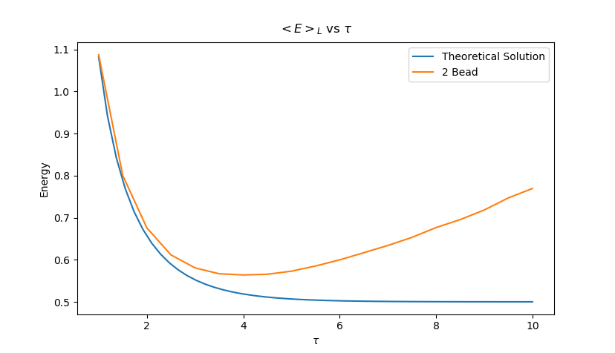
Plot Energy vs τ and compare it to the analytical result for the 2-bead action:

As τ increases the 2-Bead algorithm becomes less and less accurate. This is expected as when τ is small, we are sampling over more trajectories, leading to a more accurate calculation.
Problem 3:

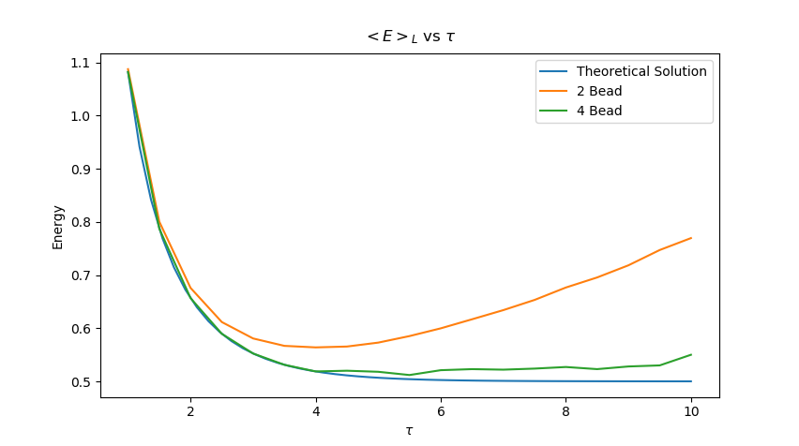
Repeat the above for a 4-bead calculation. Plot the 4-bead energy expectation values as a function of τ in the same graph as in 2.

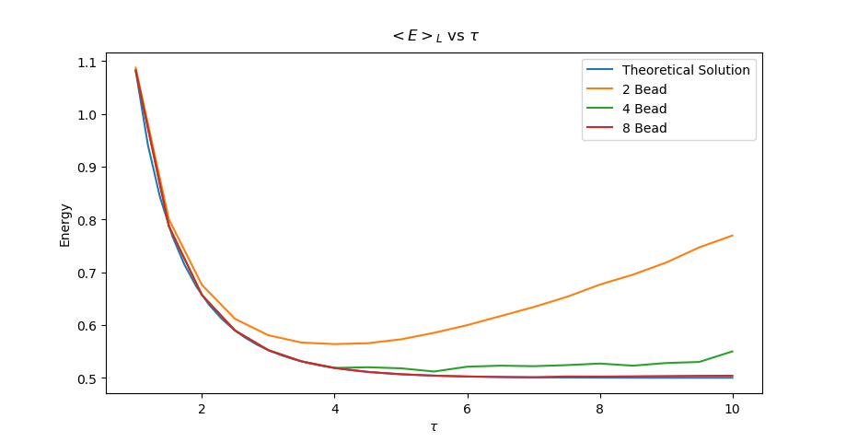
Similar to problem 2, as τ increases, our calculation becomes more inaccurate. Our 4-bead algorithm is systematically closer to the theoretical result, and it is a clear trend that the higher the bead count, the closer we will approach the ground state. This point can be further exaggerate by including the 8 bead calculation as seen below:

